Project 2

**IAM (Identity and Access Management)**

TASK 1

**IAM**: AWS Identity and Access Management (IAM) is a web service that helps you securely control access to AWS resources. You use IAM to control who is authenticated (signed in) and authorized (has permissions) to use resources.

Scenario 1:Creation of IAM account to have Full access to S3 Service

Below are the steps taken to execute the Scenario 1:

Step 1: Go to IAM dashboard:

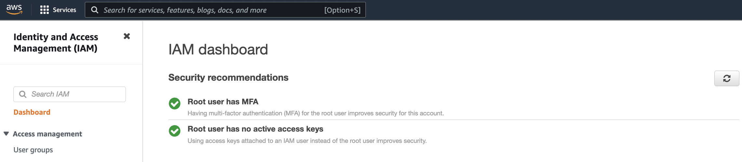

Step 2: Go to the user group, as per best practice instead of assigning permission/access to a user account it should be applied to a group. Click on ‘Create user group’. Put user group name ‘S3Admin’.

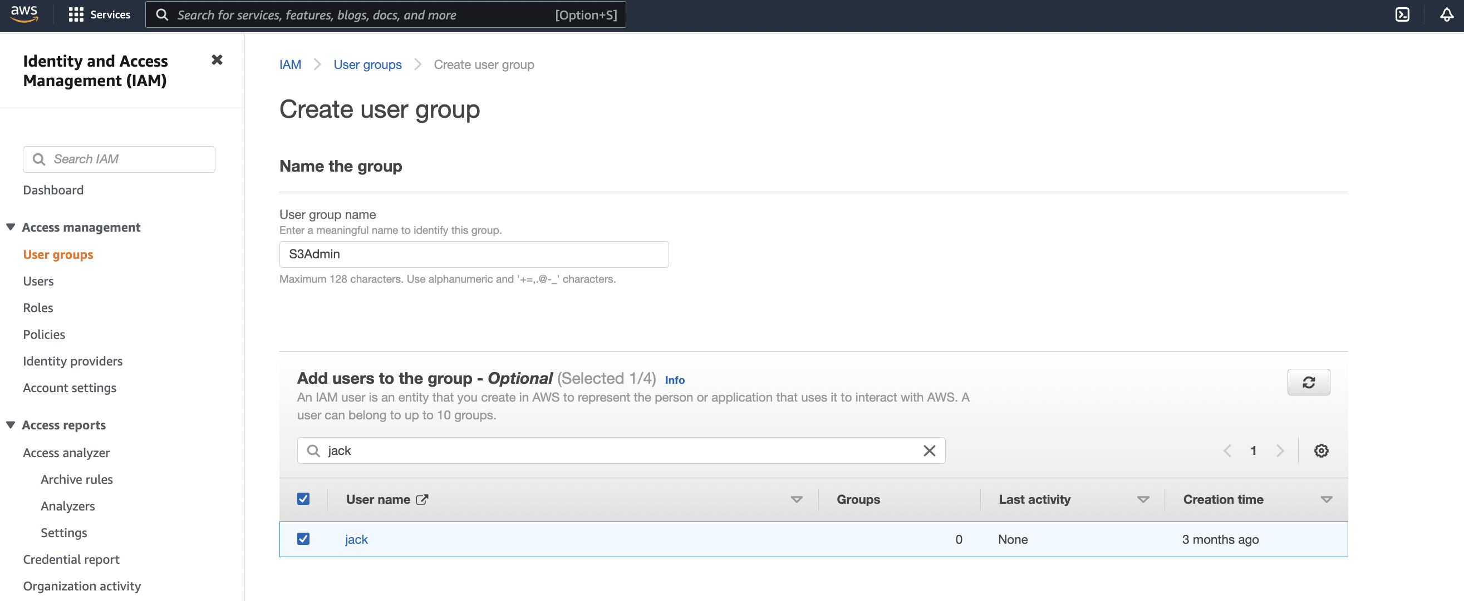

Step 3: Search for s3 in search box, and select ‘AmazonS3FullAccess’ and click on ‘Create group’.

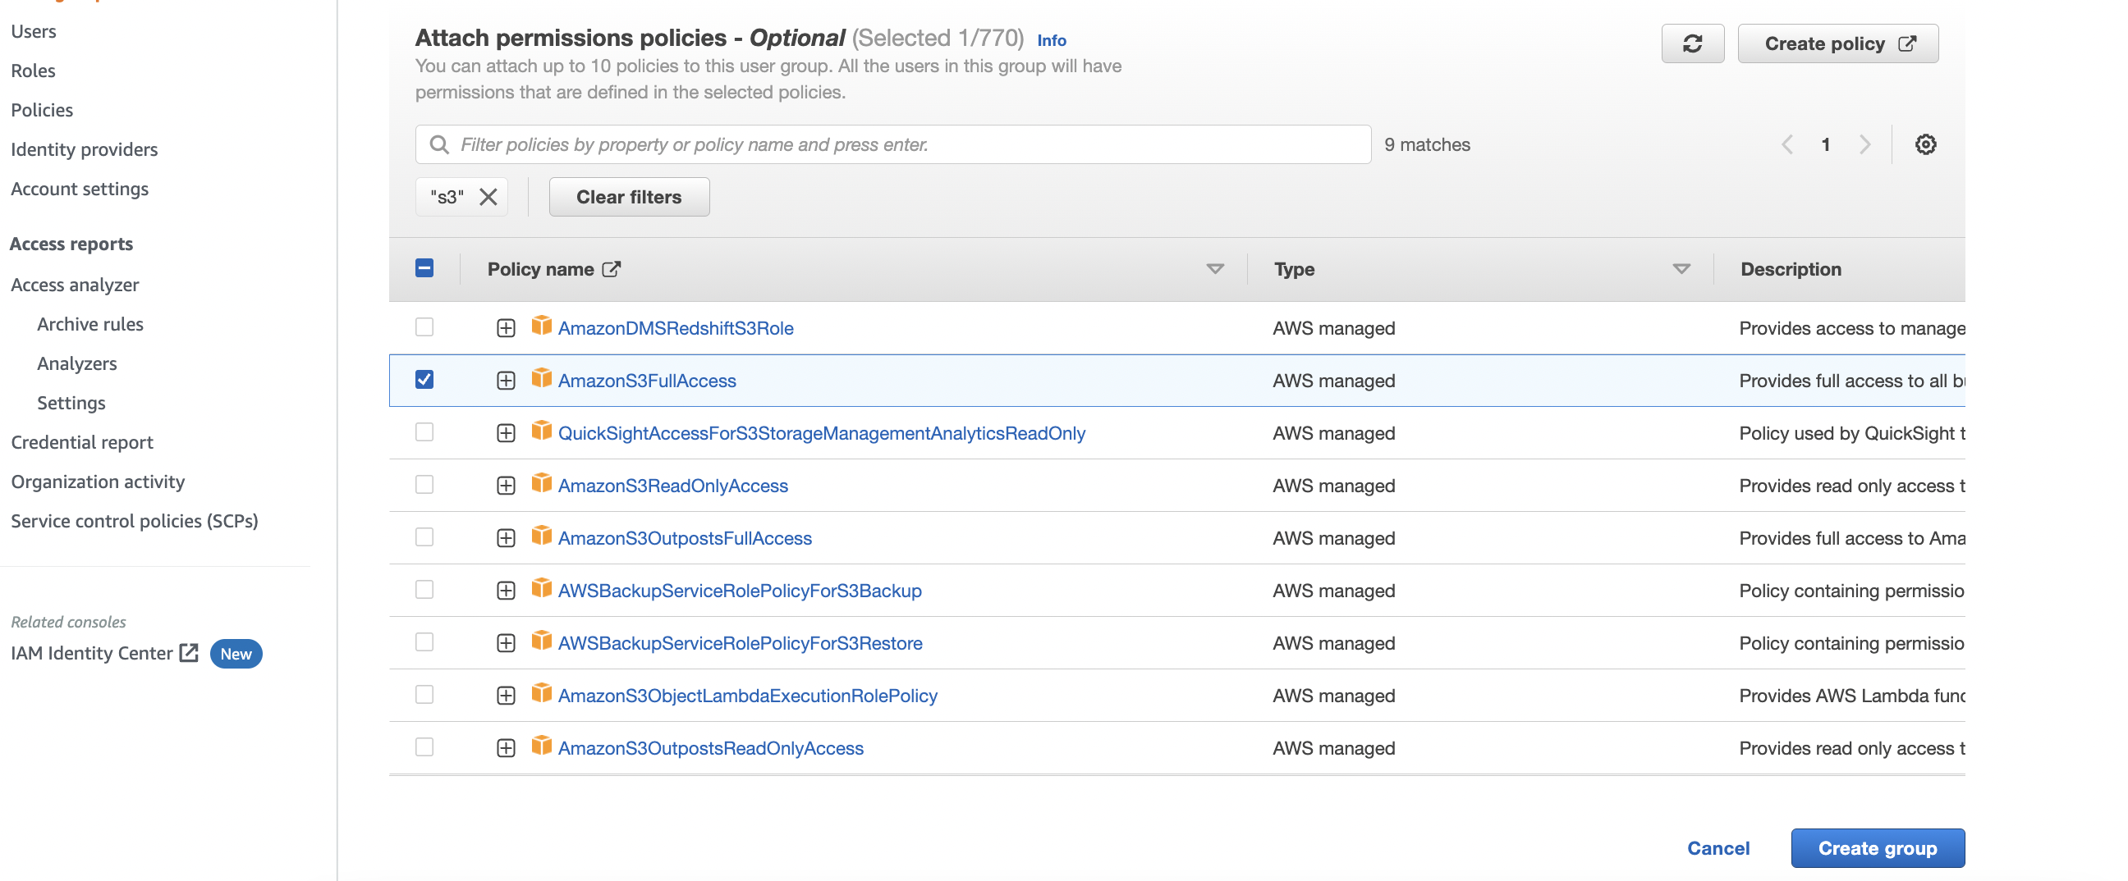

Step 4: Once group created, it will be visible on ‘user group’ page.

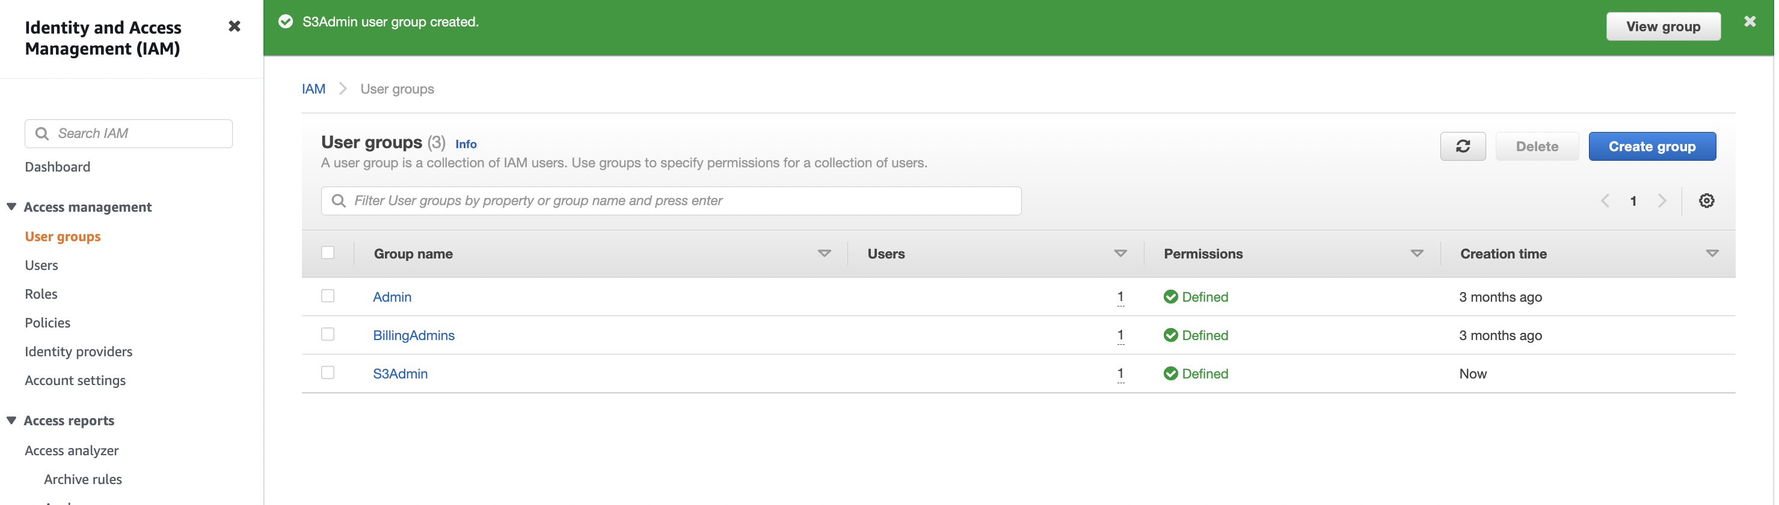

Step 5: To assign user in the group, click on the group ‘S3Admin’, click on Users and then ‘Add users’.

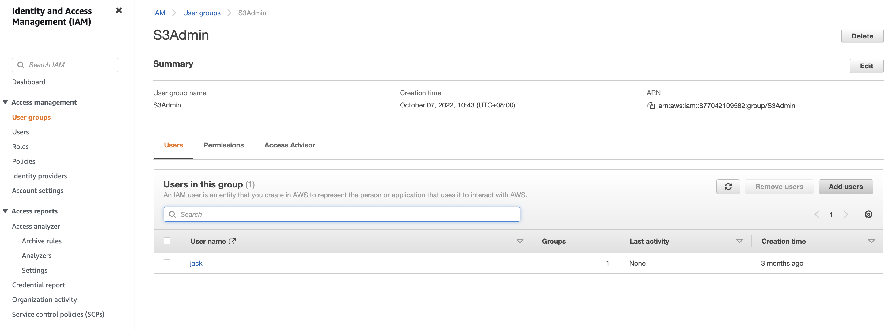

Step 6: Search the name and select it, and click on ‘Add users’.

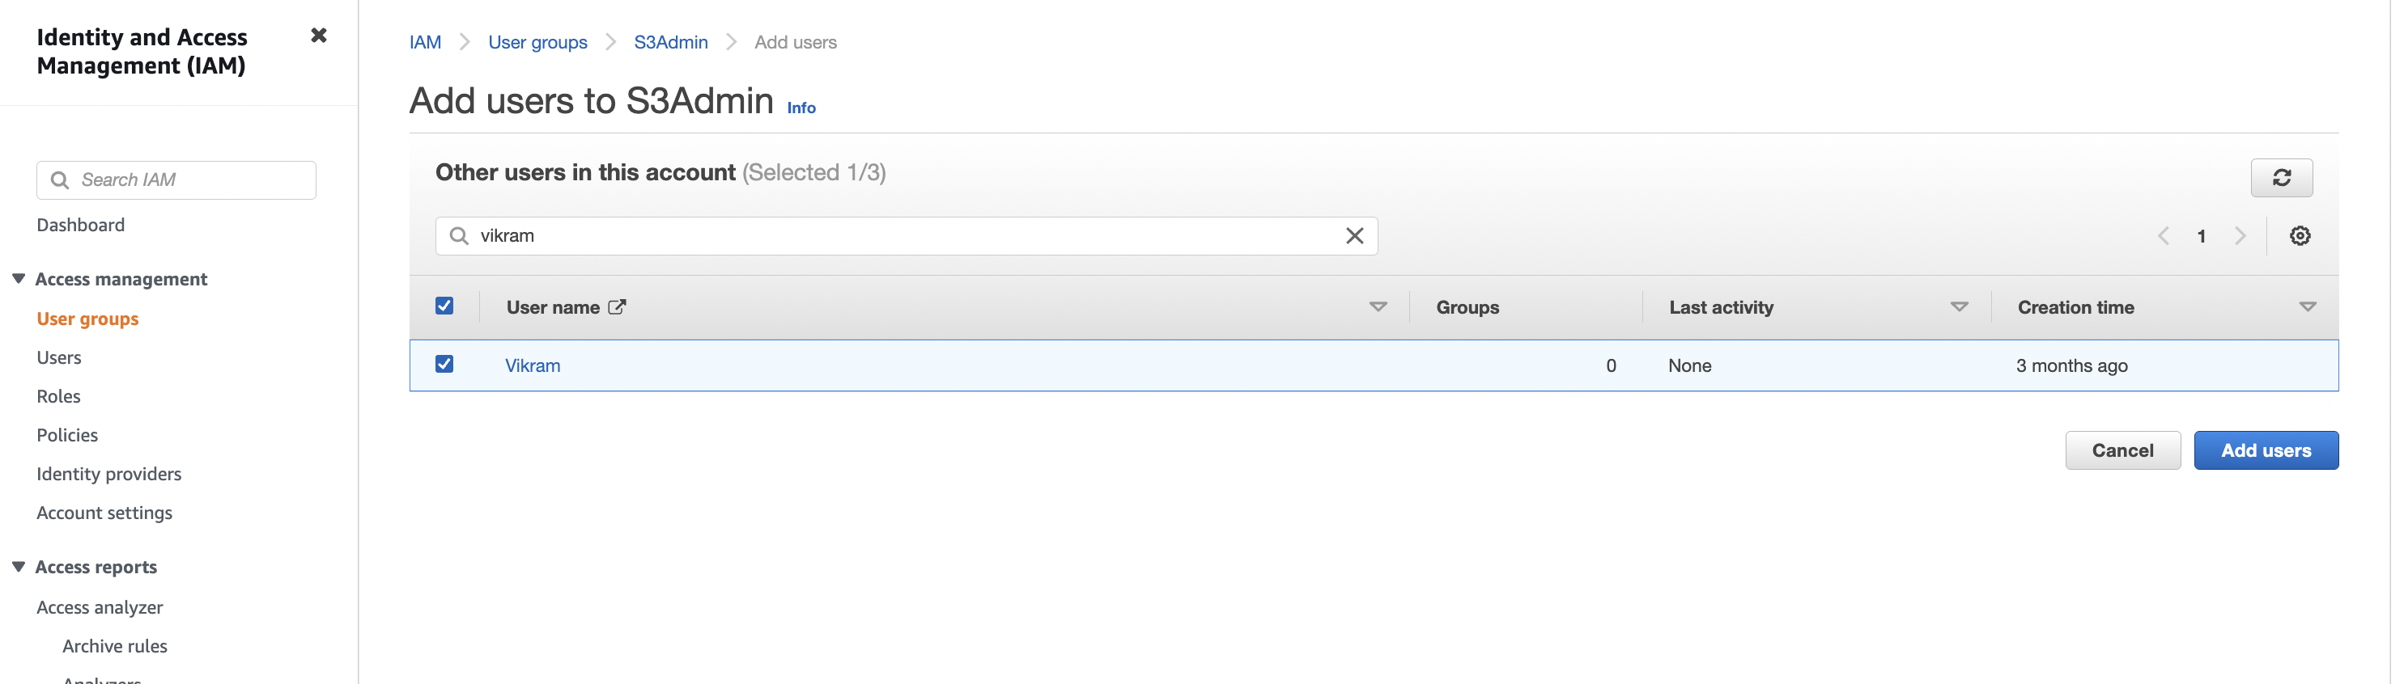

Step 7: We can see the users added in the group.

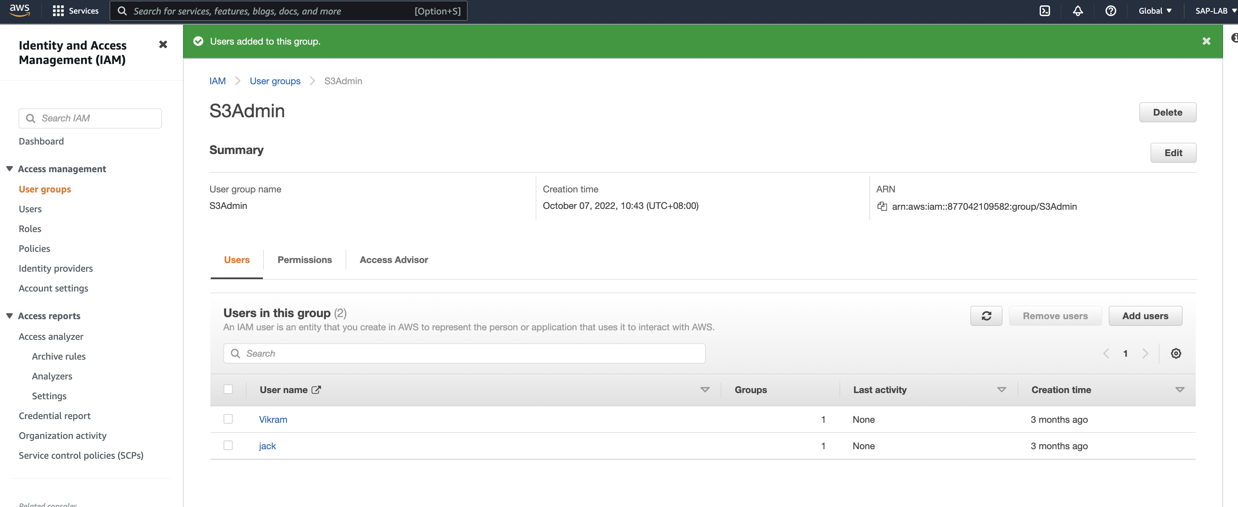

TASK 2

Custom managed Policy: Customer managed policies are standalone identity–based policies that you create and which you can attach to multiple users, groups, or roles in your AWS account. You can manage and create policies using the AWS Management Console, the AWS Command Line Interface (AWS CLI), or the IAM API.

Scenario 2: Create and attach your first custom managed policy

Step 1: On IAM dashboard click on ‘Policies’ from left pane options.

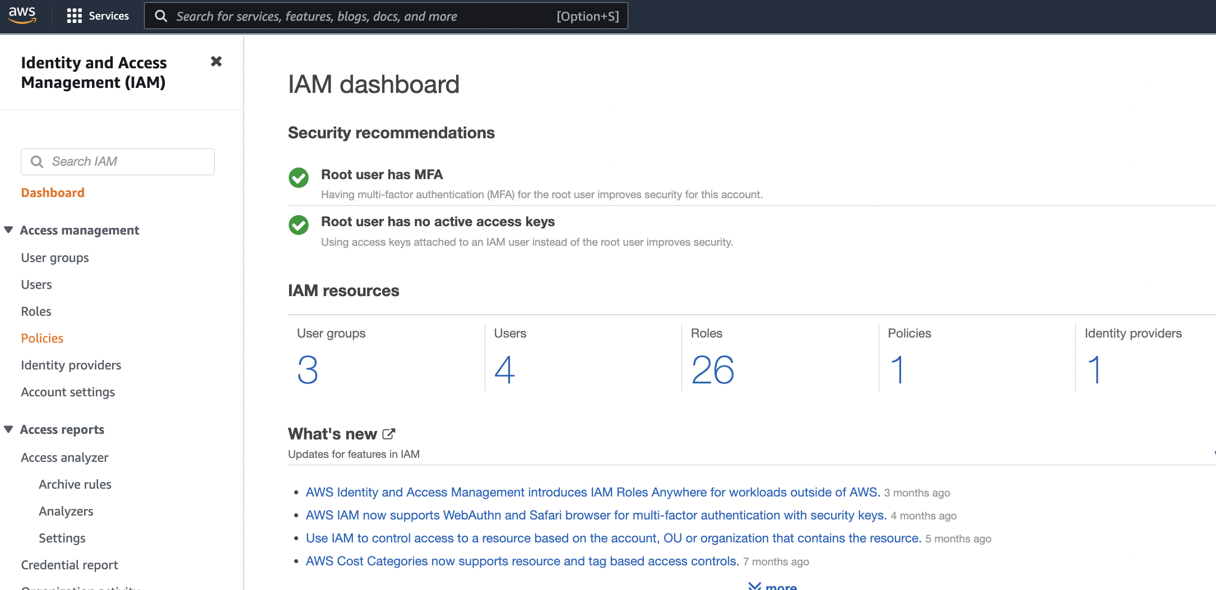

Step 2: Click on ‘Create policy’.

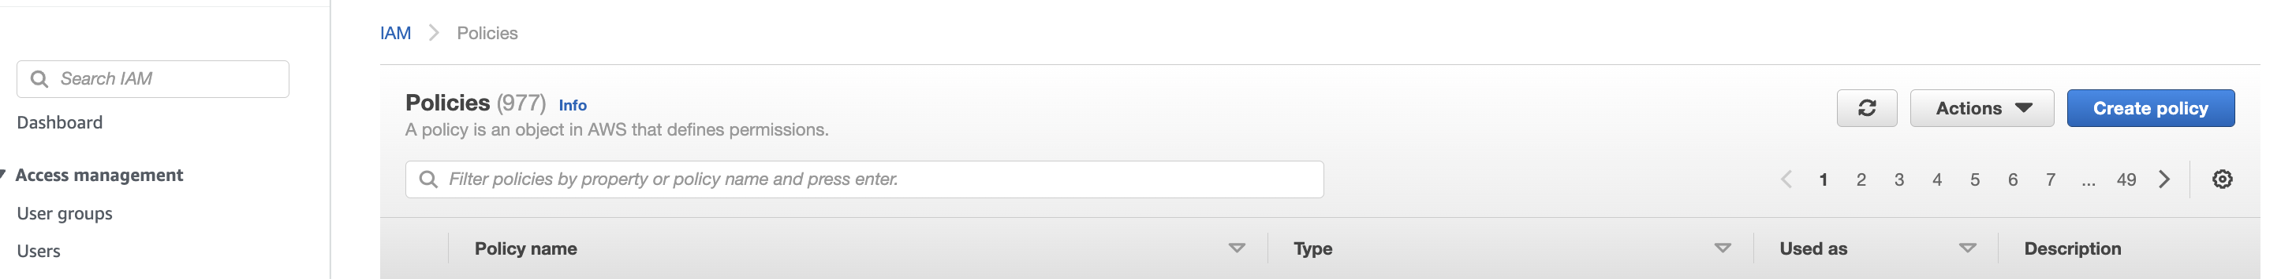

Step 3:

1. Select the desired AWS service to create policy : we opted S3
2. Actions: required actions to be performed. we opted ‘GetObject’ to check bucket object details.
3. Select resources: ‘Object’
4. Request condition: to access the details. Selected ‘MFA’.

Click on ‘Next tag’.

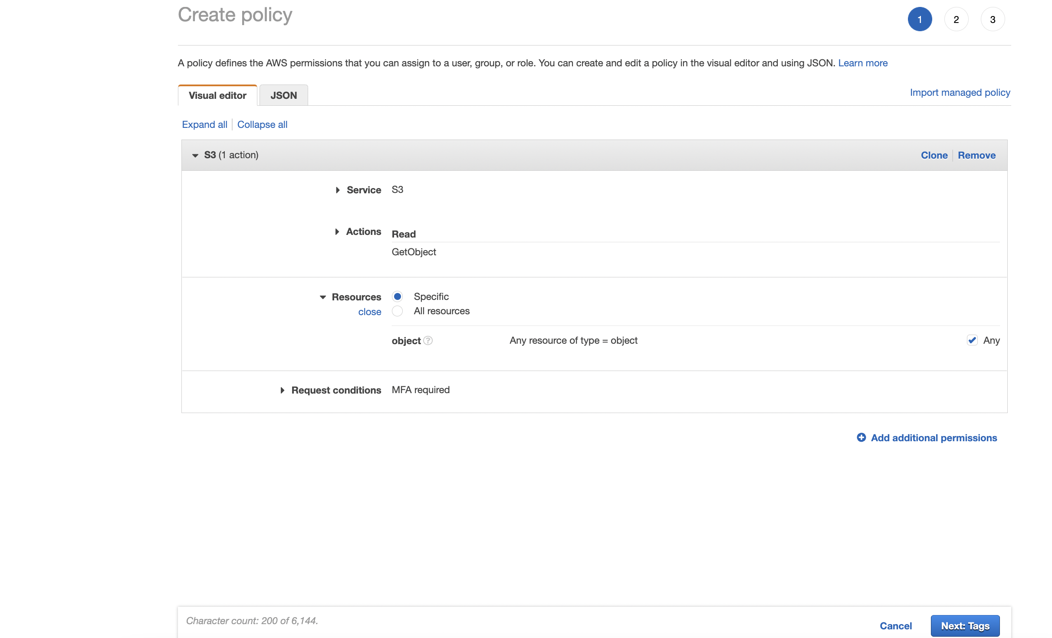

Step 4:

Add tag ‘Name’ and value ‘s3 object access’.

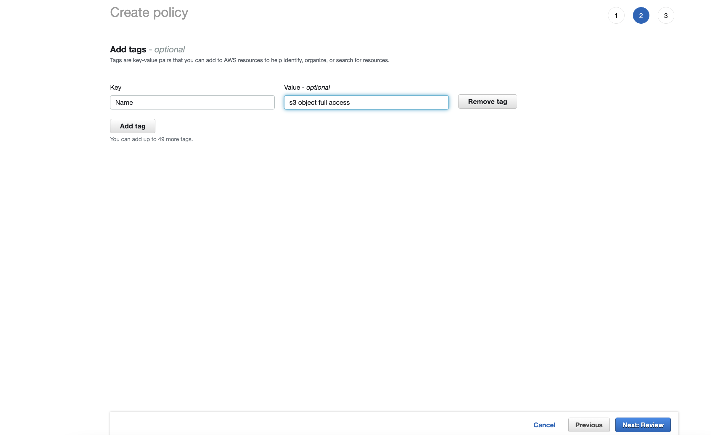

Step 5: Review the policy and click on ‘Create policy’.

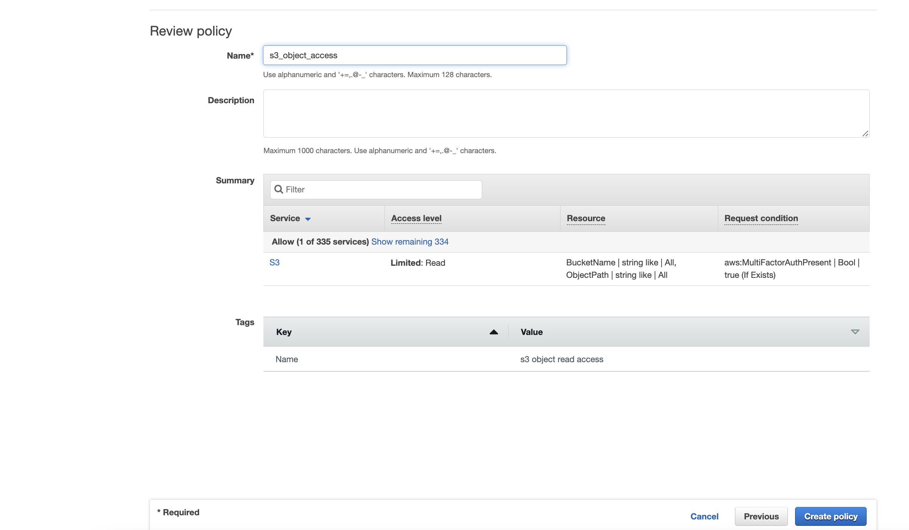

Step 6: To check the created ‘Custom managed policy’ go to policy page and search for the above created policy.

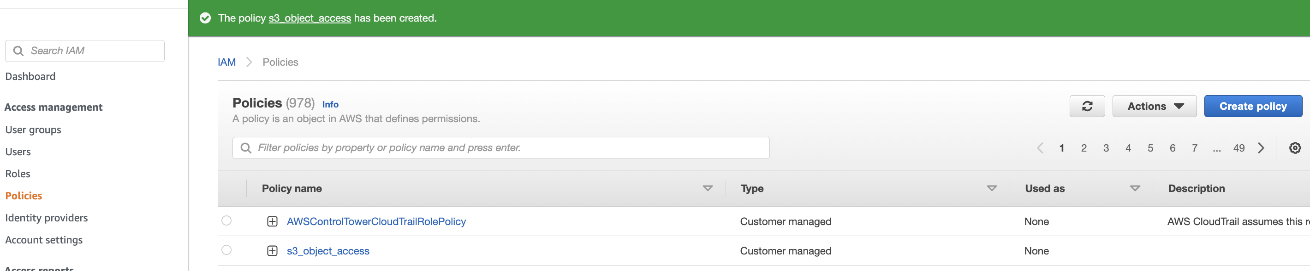

Step 7: To use above created policy, go to the group or create a new group and look for the policy and assign it.

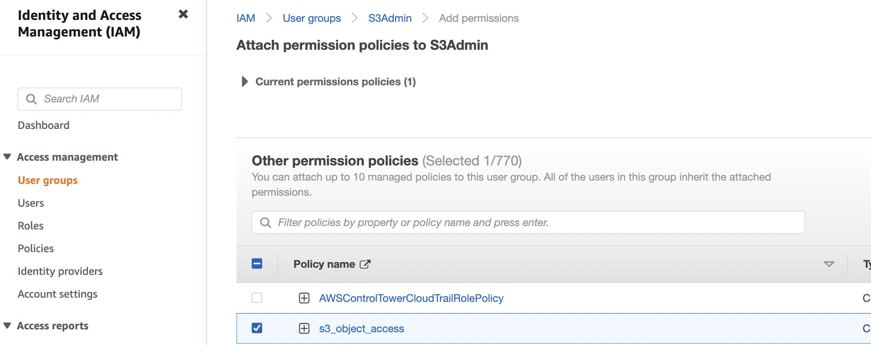

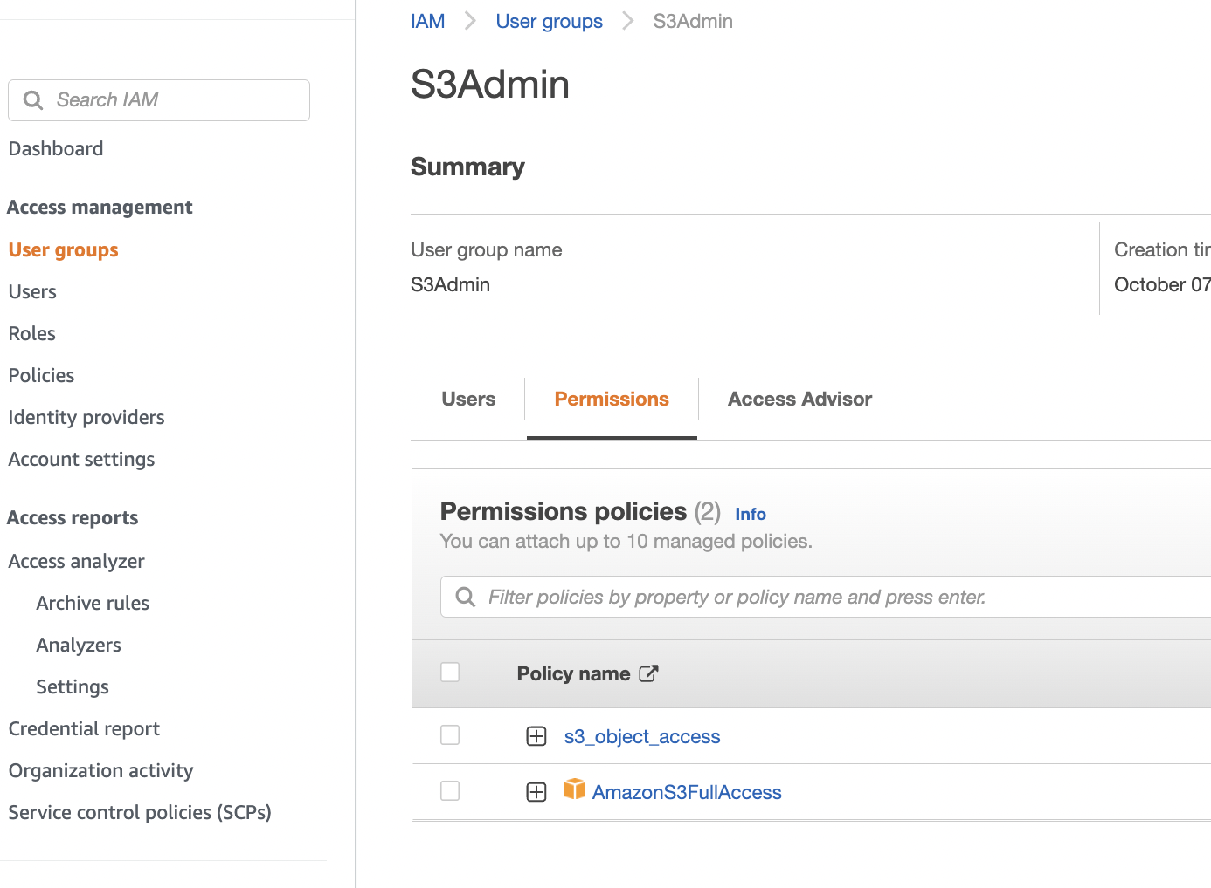

TASK 3

Scenario 3: Delegate access across AWS accounts using IAM roles

**Delegate access**: To use a role to delegate access to resources in different AWS accounts, resources in one account should be share with users in a different account. By setting up cross-account access in this way, no need to create individual IAM users in each account.

In the below executed steps, we considered 2 accounts **PROD** for live application and **DEV** for testing and development. In each account, application information is stored in Amazon S3 buckets. In **DEV** two IAM user groups: **Developers** and **Testers** are managed. Users in both user groups have permissions to work in the Development account and access resources there. From time to time, a developer must update the live applications in the **PROD** account. The developers store these applications in an Amazon S3 bucket called prodapp.

Delegating access will make Developers to access PROD recourse by assuming role, below is the scenario:

* Users in the **DEV** account (the trusted account) allowed to assume a specific role in the **PROD** account.
* A role in the **PROD** account (the trusting account) allowed to access a specific Amazon S3 bucket.
* The prodapp bucket in the **PROD** account.

Developers can use the role in the AWS Management Console to access the prodapp bucket in the **PROD** account. They can also access the bucket by using API calls authenticated by temporary credentials provided by the role.

Step 1: Obtain the DEV AWS account ID

Sign in to DEV AWS Management Console and click on the account name on most right side, a 12 digit account id will be shown there. It can be checked through Organization option also. Account id is required to provide the access in PROD role.

Step 2: Create a role in the Production Account

To allow users from DEV AWS account to access resources in PROD AWS account. Create the role in the **PROD** account and specify the **DEV** account as a trusted entity.

**Create a role in the production account that can be used by the Development account**

**Go to ‘IAM’ dashboard, select ‘Policies’** then choose **Create policy**.

1. Choose the **JSON** tab and copy the text from the following JSON policy document. Paste this text into the **JSON** text box, replacing the resource ARN (arn:aws:s3:::prodapp) with the real one for your Amazon S3 bucket.
2. {
3. "Version": "2012-10-17",
4. "Statement": [
5. {
6. "Effect": "Allow",
7. "Action": "s3:ListAllMyBuckets",
8. "Resource": "*"
9. },
10. {
11. "Effect": "Allow",
12. "Action": [
13. "s3:ListBucket",
14. "s3:GetBucketLocation"
15. ],
16. "Resource": "*arn:aws:s3:::prodapp*"
17. },
18. {
19. "Effect": "Allow",
20. "Action": [
21. "s3:GetObject",
22. "s3:PutObject",
23. "s3:DeleteObject"
24. ],
25. "Resource": "*arn:aws:s3:::prodapp/\**"
26. }
27. ]

Choose **Review policy**.

On the **Review** page, enter read-write-app-bucket for the policy name. Review the policy **Summary** and then choose **Create policy** to save your work.

The new policy appears in the list of managed policies.

In the navigation pane, choose **Roles** and then choose **Create role**. Choose the **An AWS account** role type. For **Account ID**, type the **Development** account ID.

Choose **Next: Permissions** to set the permissions associated with the role.

Select the check box next to the policy that you created previously. Then, choose **Next**.

**Tags**: Add metadata to the user by attaching tags as key-value pairs.

**Description**: Enter a description for the new role.

Review the role, choose **Create role**.

The UpdateApp role appears in the list of roles.

Check Amazon Resource Name (ARN) of the role, a unique identifier for the role. When you modify the Developers and Testers user group policy, you specify the role ARN to grant or deny permissions.

Step 3:To obtain the ARN for UpdateApp

1. In the navigation pane of the IAM console, choose **Roles**.
2. In the list of roles, choose the UpdateApp role.
3. In the **Summary** section of the details pane, copy the **Role ARN** value.

After executing above steps we have established trust between the **Production** and **Development** accounts. This happened by creating a role in the **Production** account that identifies the **Development** account as a trusted principal.

Step 2: Grant access to the role

To modify the Developers user group to allow them to switch to the UpdateApp role in Prod account

1. Sign in as an administrator in the **Development** account, and open the IAM console.
2. Choose **User groups**, and then choose **Developers**.
3. Choose the **Permissions** tab, choose **Add permissions**, and then choose **Create inline policy**.
4. Choose the **JSON** tab.
5. Add the following policy statement to allow the AssumeRole action on the UpdateApp role in the Production account.

{

"Version": "2012-10-17",

"Statement": {

"Effect": "Allow",

"Action": "sts:AssumeRole",

"Resource": "arn:aws:iam::ProductionAccountID:role/UpdateApp"

}

}

The Allow effect explicitly allows the Developers group access to the UpdateApp role in the Production account.

Choose **Review policy**.

1. Type a **Policy name** such as **allow-assume-S3-role-in-production**.
2. **Description**, type a description for the policy.
3. Choose **Create policy**.

To modify the testers user group to deny permission to assume the UpdateApp role

1. Choose **User groups**, and then choose **Testers**.
2. Choose the **Permissions** tab, choose **Add permissions**, and then choose **Create inline policy**.
3. Choose the **JSON** tab.
4. Add the following policy statement to deny the AssumeRole action on the UpdateApp role.

{

"Version": "2012-10-17",

"Statement": {

"Effect": "Deny",

"Action": "sts:AssumeRole",

"Resource": "arn:aws:iam::ProductionAccountID:role/UpdateApp"

}

}

The Deny effect explicitly denies the Testers group access to the UpdateApp role in the Production account.

Choose **Review policy**.

1. Type a **Policy name** like **deny-assume-S3-role-in-production**.
2. Choose **Create policy**.

TASK 4

MFA: AWS multi-factor authentication (MFA) is **an AWS Identity and Access Management (IAM) best practice that requires a second authentication factor in addition to user name and password sign-in credentials.** You can enable MFA at the AWS account level and for root and IAM users you have created in your account.

Scenario 4: Using multi-factor authentication (MFA) in AWS

Step 1: Go to IAM dashboard, click on ‘Add MFA’.

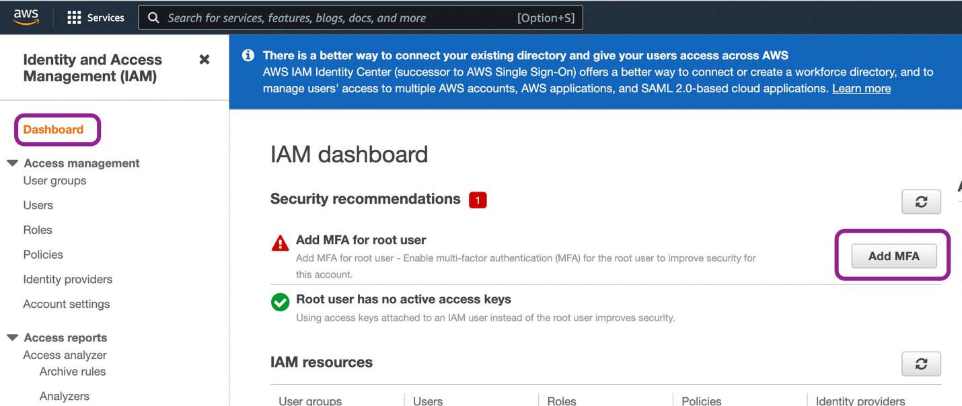

Step 2: Click on ‘Activate MFA’

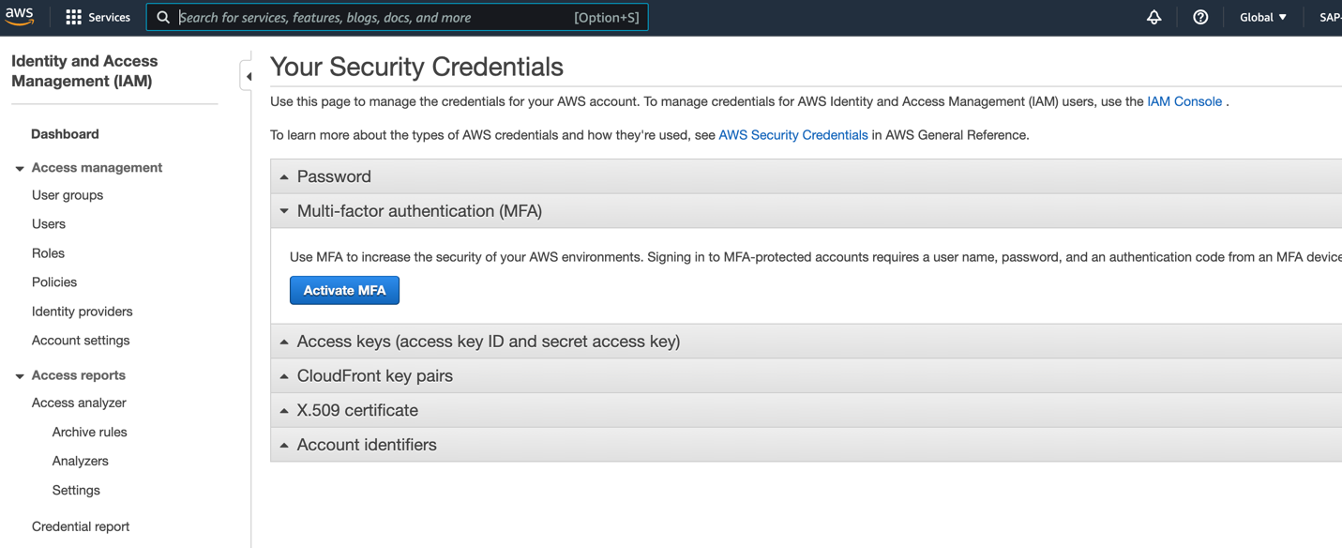

Step 3: MFA can be setup with Virtual/Physical devices. There will be 3 options to choose to proceed for MFA setup as shown in below screen. I selected ‘Virtual MFA’ device and installed ‘Microsoft Authenticator’ app in mobile.

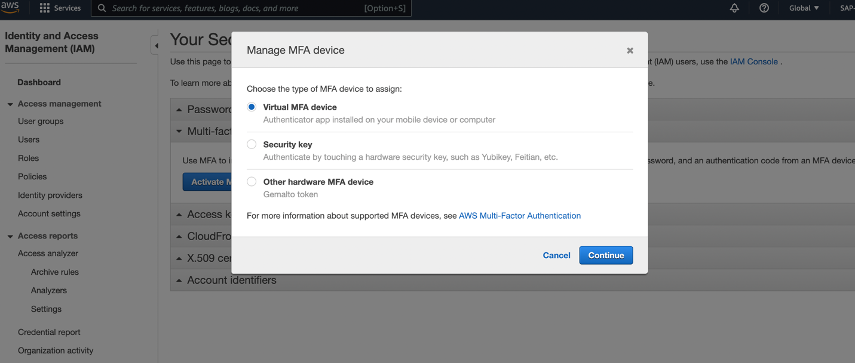

Step 4: After installing the Authenticator app click on ‘Kebab menu’ (3 vertical dots menu) in the app at top right corner. From the available options choose ‘+ Add account’, then click on personal or work or other account. After account selection choose option ‘Scan a QR code’ from pop-up window.

Step 5: Click on the show QR code on AWS console screen. Scan the QR code from mobile. After scanning , you will be able to see account alias name/ID in your authenticator app. Click on the AWS account name/ID in app.

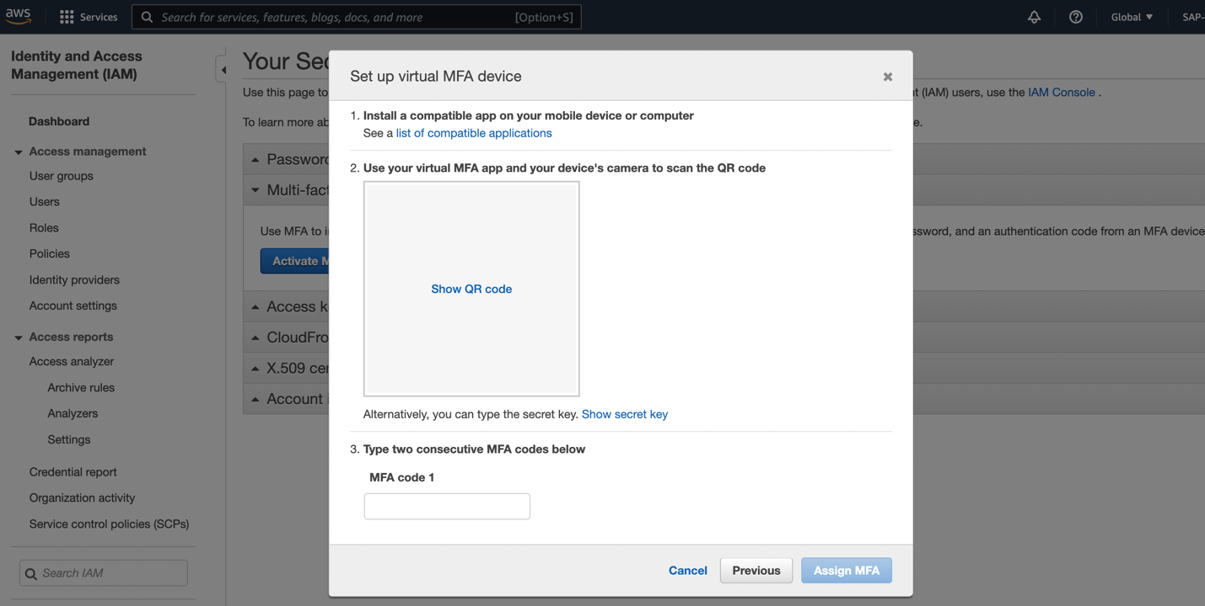

Step 6: After every specific duration a code generates in app. We need to put 2 consecutive code in the marked box in below screen ( in 3. Type two consecutive MFA codes below). And click on ‘Assign MFA’.

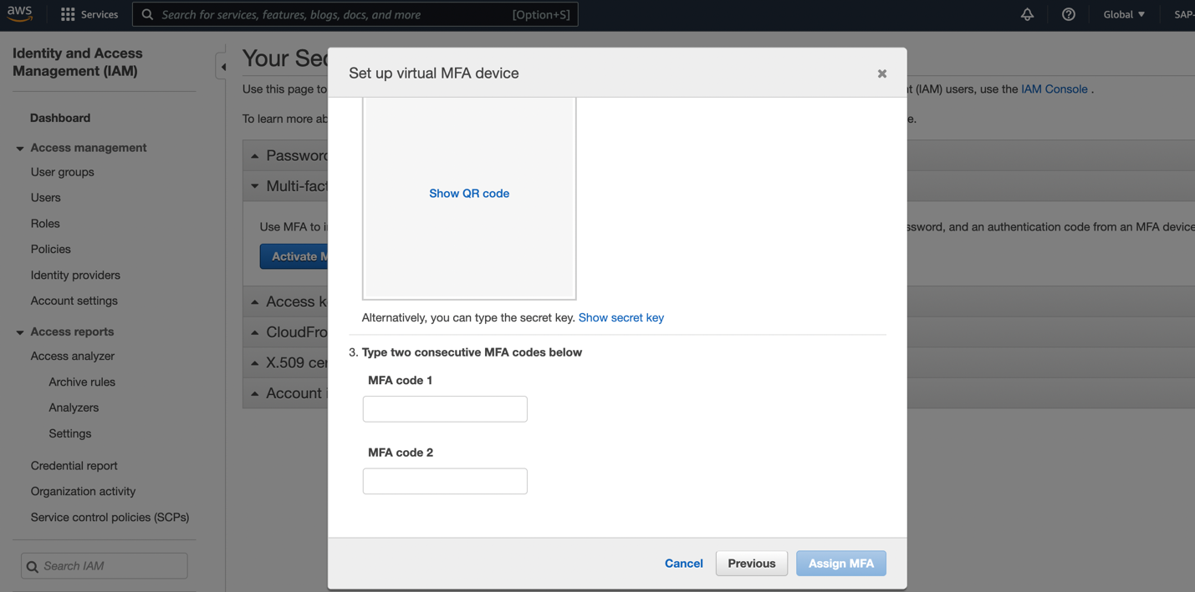

After successful setup we will receive ‘Set up virtual MFA device’ message.

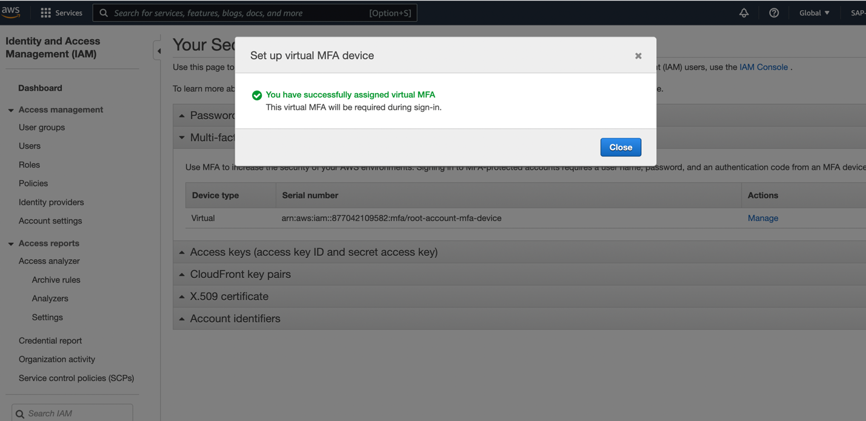

Go to IAM dashboard and check ‘Root user(IAM user if it’s not root account) has MFA’ should have green tick.

After setting up MFA, now whenever user will login to account, user needs to provide MFA from the authenticator App where we have scanned our account QR code.

